

**VIRTUAL CHATROOM**

CN Project



**BASIC TECHNIQUES AND METHODOLOGY**

While making this project, we made use of:

* dictionaries in order to store the client information and for mapping the names of the clients
* the time module that allowed us to make our sleep function
* command prompt (in case of Windows) and terminal (in case of Ubuntu) for passing arguments about the client’s name, port number and the server it wants to connect with
* to send files, we made used the general code for sending and receiving files and used the pathlib module which is an object oriented interface to the filesystem
* to connect the clients with the server, we made use of the python socket module
* we also made use of threading in python
* queuing module was also used to aid the threading process
* Initially we had problems in running our code on Windows, so we had to run our code on Ubuntu. Later on, we implemented threading on client side that allowed us to interface with the underlying operating system, be it Windows or Linux

**ANALYSIS**

* If the wrong sever address is given

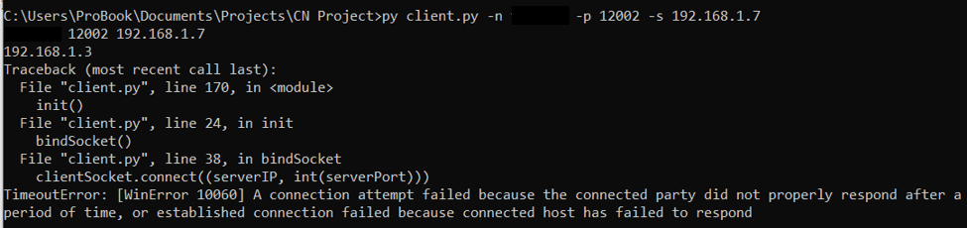

* Successful connection

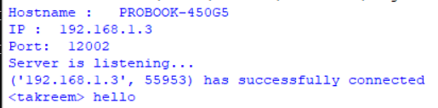

* The client can start the file transfer process by \sendfile
* In case of file transfer, if the file is not present, an error message will be generated
* On successful transfer, we will be informed about its transfer
* When a client1 blocks client2, client1 will not be able to view messages sent by client2
* After the client2 gets unblocked, client1 can see messages sent by client2
* The client can snooze the server by sending the \sleep\**(time)** message
* The client can also change his name any number of times at any time by \name\**(newname)**
* The client can exit the chat by sending the \quit message. Other clients will be informed of his exit.